Reset Bill Number On Pos
Overview: Reset Bill Number is a feature that allows you to reset the bill number sequence in your billing system. It is usually used at the beginning of a new financial year or when a new bill series is required. After the reset, all new bills will be generated starting from the new bill number you set.

Path : Petpooja pos >> Click on sidebar menu >> operation >> Setting >> Reset bill no,

Steps to reach Reset bill no.

Step 1 : petpooja pos Steps to reach reset bill no : Open petpooja pos app Click on side bar

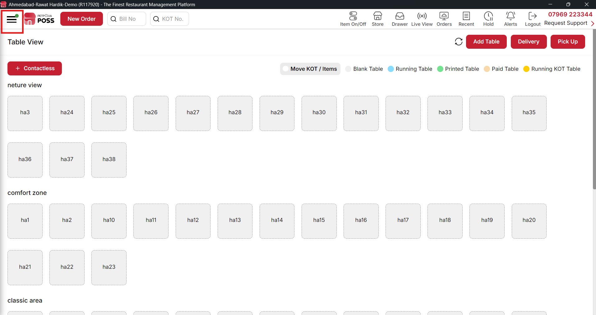

{ Image Name: Petpooja pos side bar option,
Description: The highlighted image show sidebar option in petpooja pos }

Step 2 : After that click on operation option that show in inside the sidebar

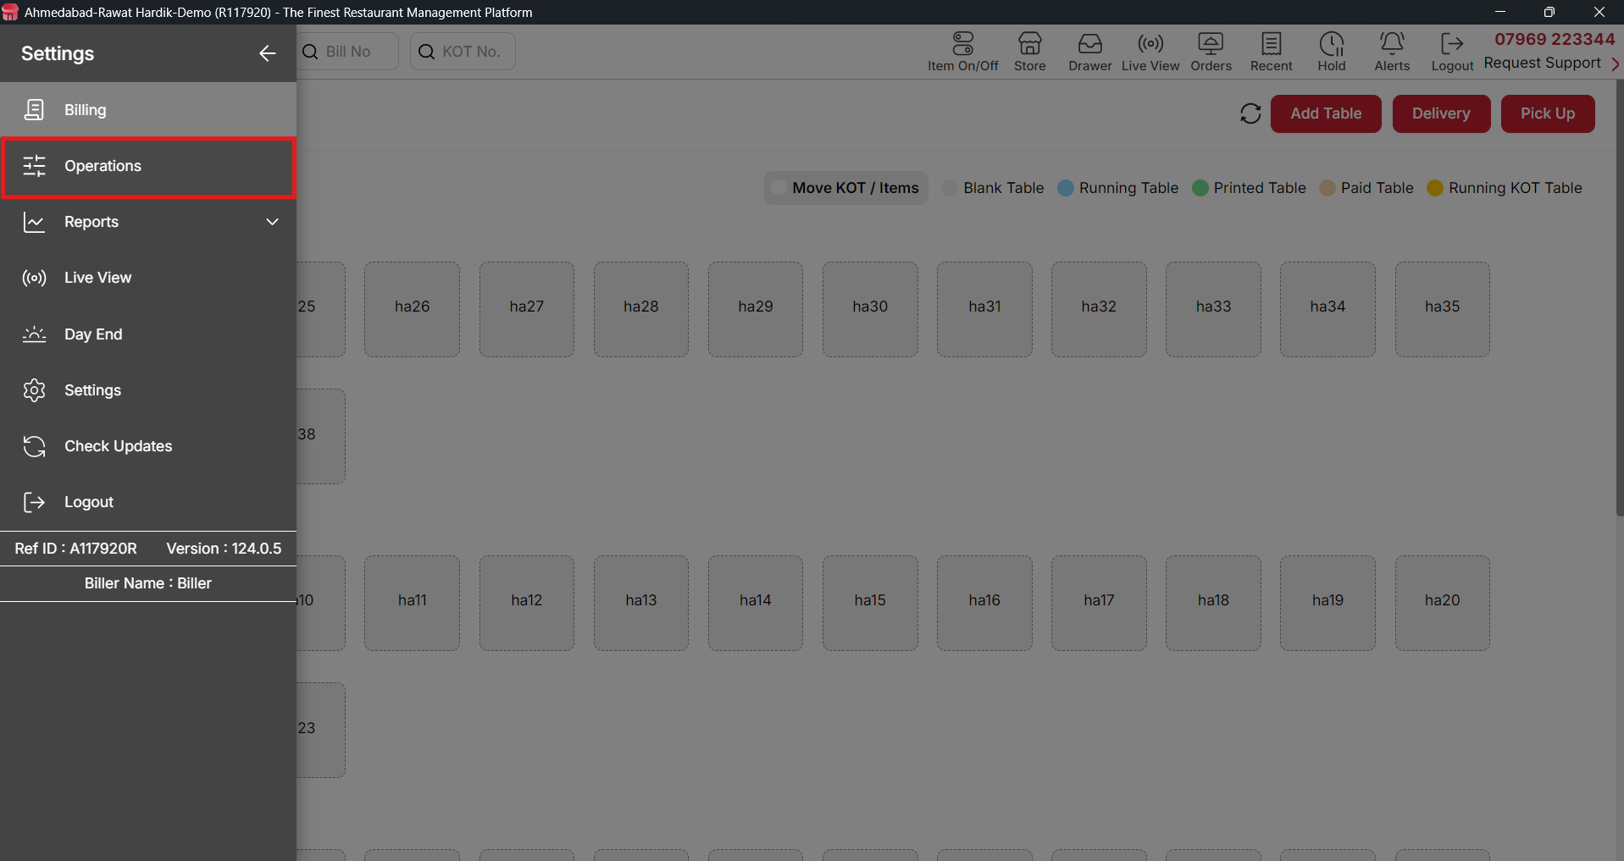

{ Image Name: operation option
Description: The highlighted image show operation option in sidebar }

Step 3 : After that click on setting option in side the operation

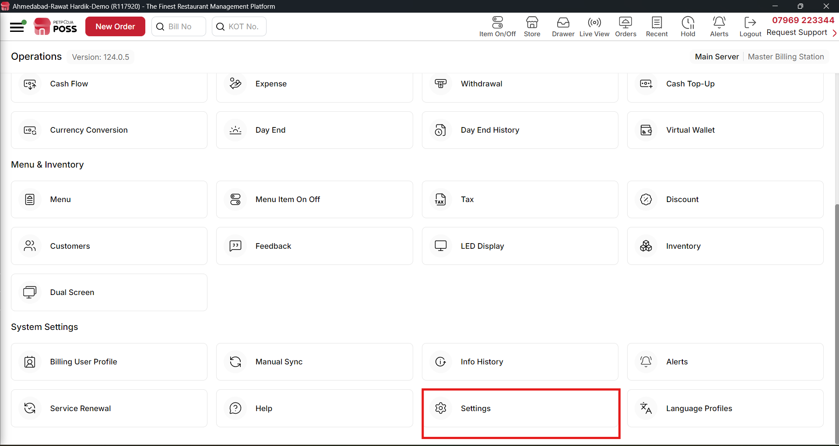

{ Image Name: Setting option in side the operation,
Description: The highlighted image show Setting option in side the operation }
Step 4 : After that click on rest bill no option

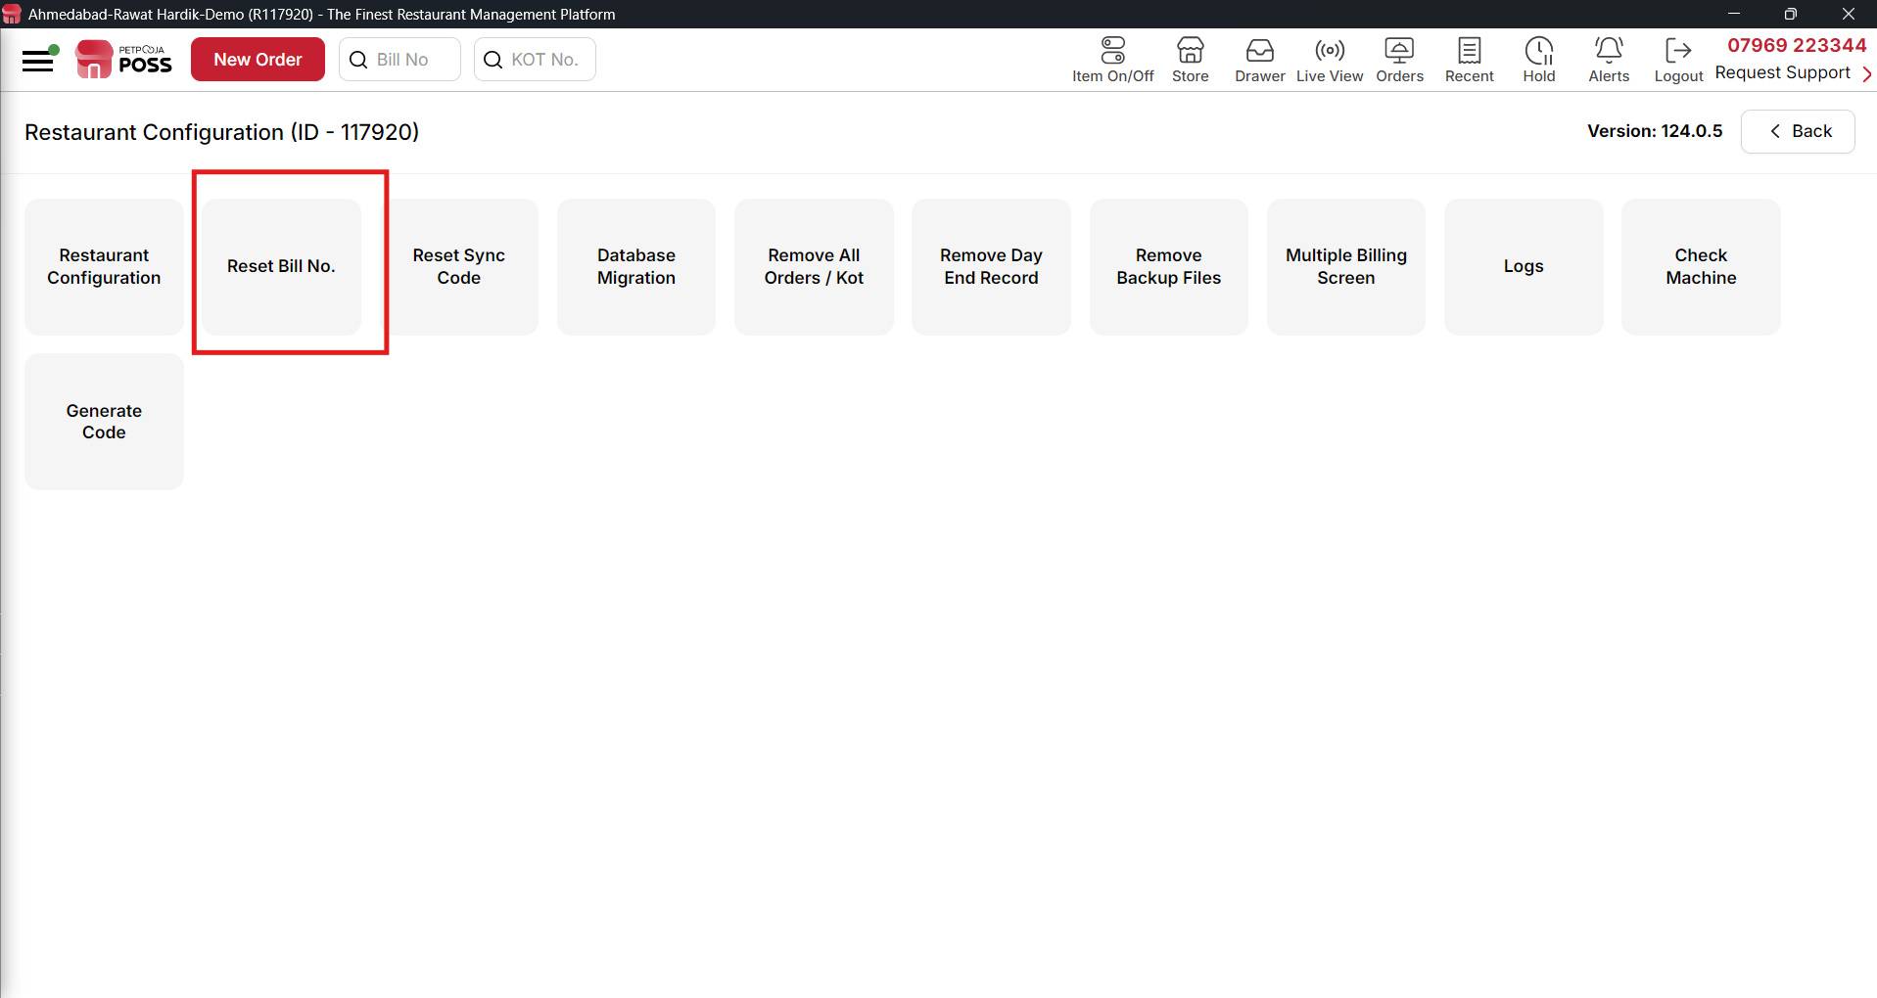

{ Image Name: Reset bill no option under the setting,
Description: The highlighted image show Reset bill no option under the setting }

Step 5 : After that, enter your Billing POS password (the same password you use to log in to the POS). Then, enter a reason, as this field is mandatory.
Next, choose how often you want the bill number to reset:
- Yearly
- Monthly
- Weekly
- Daily
- None (This means the bill number will continue without resetting.)
After selecting the reset option, choose the start date and month, then click on "Save".
Important: If even one bill has already been generated today, the reset will not take effect today. The new bill number sequence will start from the next day, not the current day.

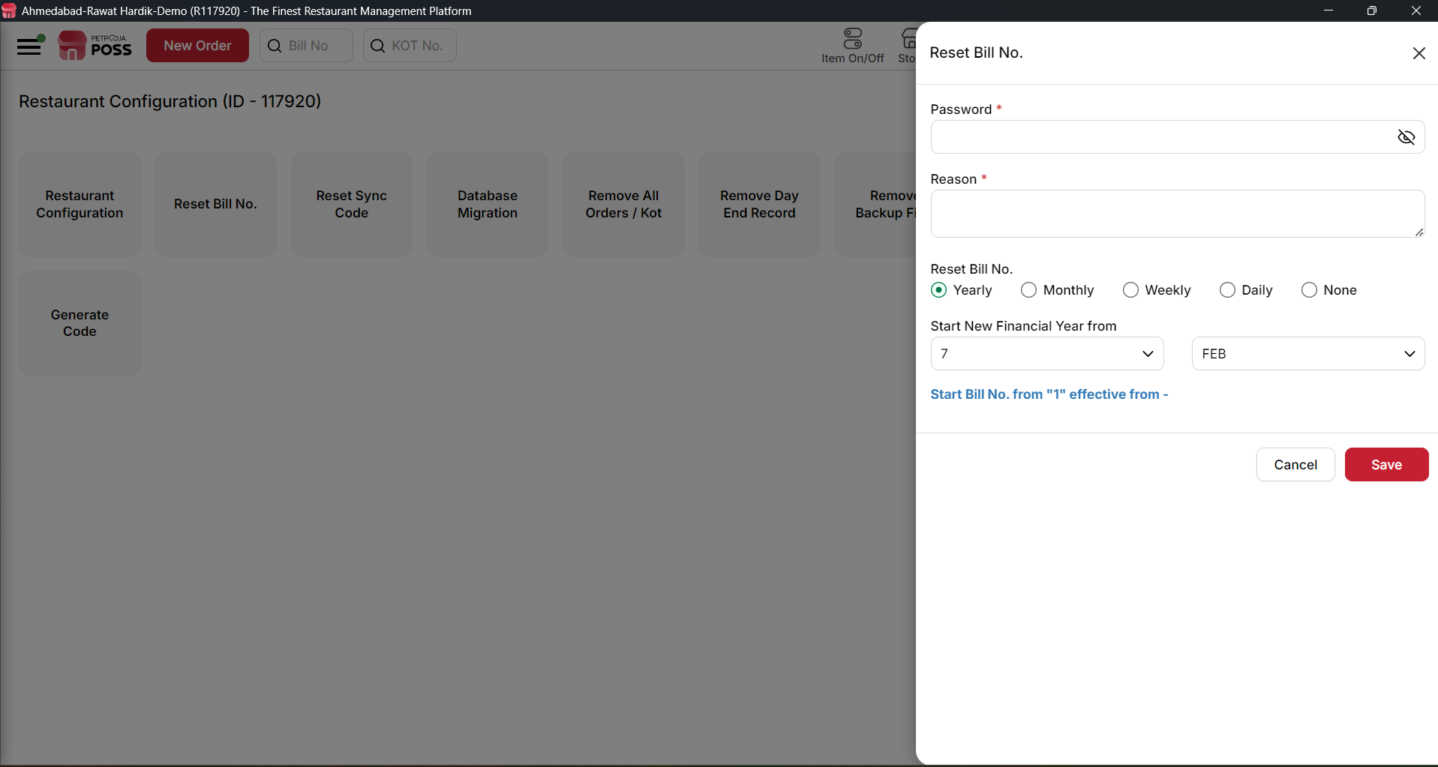

{ Image Name: reset bill number processing page ,
Description: The highlighted image show reset bill number processing page }

